



Data Structures & Algorithm
LAB MANUAL

Disclaimer: The content is curated from online/offline resources and used for educational purpose only
Multi Dimensional Arrays in Python
Objective:
To implement and manipulate 1-D, 2-D, and 3-D arrays.
Equipment Required:
- Computer with Python installed, text editor/IDE.
- Computer with Python and NumPy.
Prerequisites:
- Basic understanding of variables, loops, and data types.
- Looping, indexing, NumPy basics.
Problem Statement:
Implement different dimentional arrays and execute few operations

Procedure:

- Write a program to find the maximum element in a 1-D array.
Procedure:
- Create a 1-D array with integer values.
- Initialize a variable to hold the maximum value.
- Traverse the array and update the maximum value.
- Display the result.
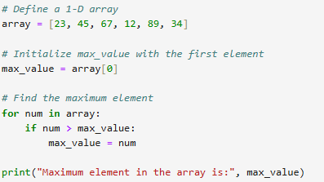
- Reverse the 1-D array.
Procedure:
- Create a 1-D array.
- Use slicing or a loop to reverse the array.
- Print the reversed array.
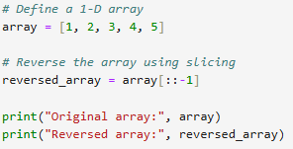
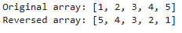

- Implement matrix addition.
Procedure:
- Take two 2-D arrays (matrices) of the same size.
- Add corresponding elements.
- Store the result in a third matrix.
- Print the result.
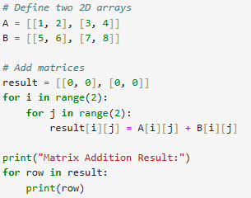
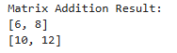
- Implement matrix multiplication.
Procedure:
- Define two compatible 2-D matrices.
- Multiply row elements of matrix A with column elements of matrix B.
- Store results in a new matrix.
- Print the product matrix.
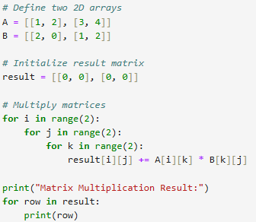
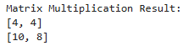

- Create and display elements of a 3-D array.
Procedure:
- Define a 3-D array using nested lists.
- Use three nested loops to display all elements.
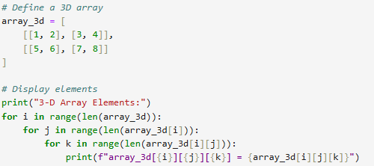
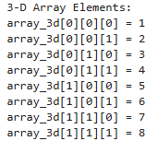

- Sum all elements in a 3-D array.
Procedure:
- Traverse the 3-D array using three nested loops.
- Accumulate the sum of all elements.
- Print the total sum.
